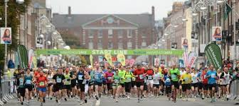 | Dublin Bus Diversions Document  Dublin Marathon  Sun, Oct 29, 2023  Start time 08:45hrs.

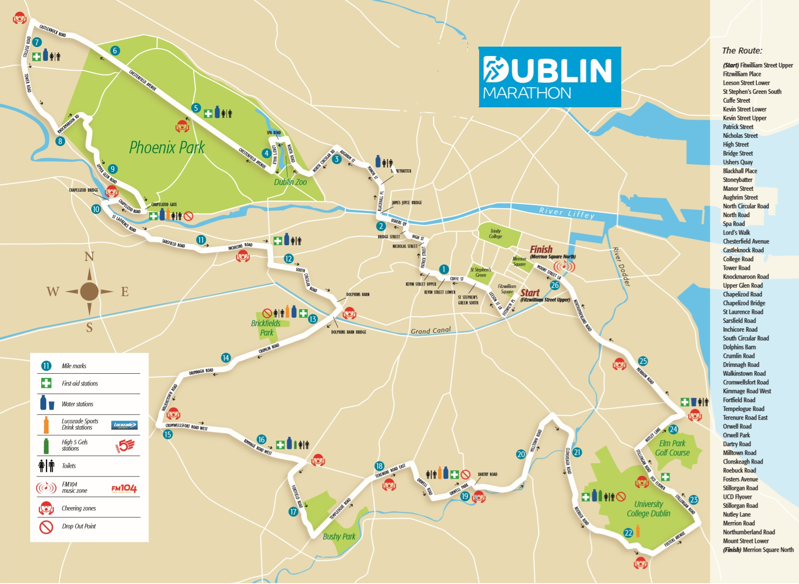

Dublin Marathon
No adjustments are to be made to the routing of diversions on the day without prior consent of the Chief Inspector on duty in the relevant area.

Times for the implementation and removal of diversions are a guide and may vary on the day.

Dublin City Marathon Pre & Post Race Diversions

All day Saturday
and again
From first bus Monday until 1800hrs:
Due to a road closure on Merrion Square North, to facilitate the Marathon, the following diversions will apply.

Route | Description
4 | Route 4  Route 4: to Harristown normal route to Lower Mount Street then divert left to Merrion Square East right to Merrion Square South right to Merrion Square West left to Clare Street and normal route.  Route 4: to Monkstown normal route to South Leinster Street then divert to Lincoln Place, Merrion Street Lower Merrion Square west, south, east right turn (to be granted by Gardaí) to Mount Street and normal route.
7 | Route 7  Route 7: to City will operate to Lower Mount Street left to Merrion Square East right to Merrion Square South right to Merrion Square West left to Clare Street and normal route.  Route 7: from City normal route to South Leinster Street then divert to Lincoln Place, Merrion Street Lower Merrion Square west, south, east right turn (to be granted by Gardaí) to Mount Street and normal route.
15a/b & 26 | Route 15a/b & 26: From City Depart terminus divert right to Fitzwilliam Street, Baggot Street, Pembroke Street, Leeson Street, St Stephens Green, Ely Place, Hume Street, Merrion Street upper, Merrion Square West to Clare Street and normal route.

Dublin City Marathon Race Route

Please Note the Marathon Route:

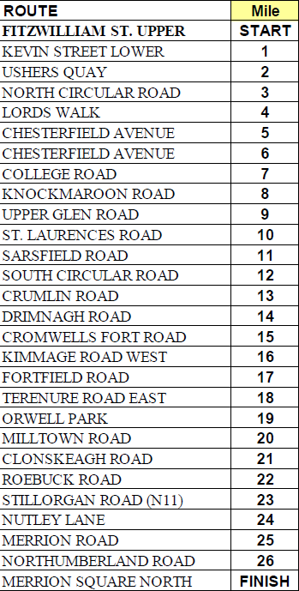

Dublin City Marathon RACE DAY Diversions

Controllers to enter route curtailments in preparation prior to race start

Route | (Diversions from 0830hrs until road reopened by Chief Inspector on the ground in liaison with Gardaí unless otherwise stated in respective route diversion)
4 | Route 4  Route 4: toward Blackrock: normal route to D’Olier Street then divert left to Townsend Street, Sandwith Street Lower, Pearse Street, Ringsend Road, Irishtown Road, Tritonville Road, Sandymount Road, Seafort Avenue, Seafort Terrace, Dromard Terrace, Strand Road, Merrion Gates and normal route.  Route 4: toward Ballymun: normal route to Merrion Gates then divert to Strand Road, Beach Road, Church Street, Irishtown Road, Ringsend Road, Pearse Street to Westmoreland Street and normal route.
7 | Route 7  Route 7: toward City: normal route to Merrion Gates then divert to Strand Road, Beach Road, Church Street, Irishtown Road, Ringsend Road, Pearse Street to Westmoreland Street and normal route.  Route 7: toward Sallynoggin: normal route to D’Olier Street then divert left to Townsend Street, Sandwith Street Lower, Pearse Street, Ringsend Road, Irishtown Road, Tritonville Road, Sandymount Road, Seafort Avenue, Seafort Terrace, Dromard Terrace, Strand Road, Merrion Gates and normal route.
9 | Route 9:  Route 9: From Charlestown until 1030hrs: operate to and from Parnell Square Only.  Route 9: From Walkinstown until 1030hrs: No Service  Route 9: From Charlestown after 1030hrs normal route to Kimmage Road, then divert right to Sundrive Road, left to Clogher Road, Kildare Road, Drimnagh Road, Long Mile Road, Walkinstown Ave, St Peter’s Road and normal route.  Route 9: From Walkinstown after 1030hrs: normal route to St Peter’s Road then divert to Walkinstown Ave, Drimnagh Road, Kildare Road, right to Sundrive Road, left to Kimmage Road and normal route.
11 | Route 11 (No service before 1030)  Route 11: Southbound From 1030hrs normal route to Leeson Street then divert to Donnybrook, Stillorgan Road, Kilmacud Road Lower to Kilmacud Road Upper and normal route.  Route 11: Northbound from 1030hrs normal route to Kilmacud Road Upper then divert to Kilmacud Road Lower, Stillorgan Road, Donnybrook to Leeson Street and normal route.
13 | Route 13  Route 13: Southside from Grangecastle before 1030hrs normal route Naas Road then divert left onto Kylemore Road left to Ballyfermot Road, Kennilsfort Road, right to Chapelizod-By-Pass, Concolbert Road left to South Circular Road right to Conyngham Road and terminate before Garage.  Route 13: Southside to Grangecastle before 1030hrs Conyngham Road, left to South Circular Road, Concolbert Road, Chapelizod-By-Pass, Kennilsfort Road, Ballyfermot Road, Kylemore Road to Naas Road and normal route.  Route 13: Northside from Ballymun before 1030hrs normal route to Parnell Square East and terminate.  Route 13: Northside to Ballymun before 1030hrs depart Parnell Square West to normal route  Route 13: To Grangecastle after 1030hrs normal route to High Street then divert right to Bridge Street, South Quays to John’s Road, Concolbert Road, Chapelizod-By-Pass left onto Kennilsfort Road, Ballyfermot Road right onto Kylemore Road right onto Longmile Road, Naas Road and onto normal route.  Route 13: To Ballymun after 1030hrs normal route to Naas Road then divert left onto Kylemore Road left onto Ballyfermot Road, Kennilsfort Road, right to Chapelizod-By-Pass, Concolbert Road, John's Road, North Quays right to Bridge Street, High Street back to normal route.
14 | Route 14  No service northside until after 1030  Route 14: up to 1030 hrs Southside toward City normal route to Braemor Park then divert right to Orwell Road right to Lower Churchtown Road left to Upper Churchtown Road onto Taney Road right to Drumartin Road lower to Lower Kilmacud Road left to Stillorgan Road onto Donnybrook Road after Leeson Street Bridge turn left onto Adelaide Road and terminate.  Route 14: up to 1030 hrs Southside toward Dundrum from Adelaide Road Leeson Street to Donnybrook, Stillorgan Road Kilmacud Road, Drumartin Road, Taney Road, Churchtown Road, Orwell Road to Braemor Park and normal route.  Route 14: Southside From 1030 hrs toward Ardlea Road normal route to Braemor Park then divert right to Orwell Road right to Lower Churchtown Road left to Upper Churchtown Road onto Taney Road right to Drumartin Road lower to Lower Kilmacud Road left to Stillorgan Road onto Donnybrook Road continue to Leeson Street, Stephens Green East, Dawson St, Nassau Street, Grafton Street, to Westmoreland Street and normal route.  Route 14: Southside From 1030 hrs toward Dundrum normal route to College Street then divert to Nassau Street, Kildare Street, St. Stephens Green, Leeson Street, Donnybrook, Kilmacud Road, Drumartin Road, Taney Road, Churchtown Road, Orwell Road to Braemor Park and normal route.
15 | Route 15  Route 15: [all Broadstone cars] Northside: until 1000hrs operate to and from Eden Quay via Talbot Street, Marlborough Street.  Route 15: [all Donnybrook cars] Southside: until 1000hrs operate to and from Hatch Street.  Route 15: Southside: after 1000hrs to Stocking Avenue Normal route to Rathmines Road Lower then divert to Grosvenor Road, Kenilworth Road, Larkfield Park, Sundrive Road, Clogher Road, Kildare Road, Drimnagh Road, Long Mile Road, Walkinstown Avenue, St Peters Road, Greentrees Road, Templeville Road, Templeogue Village to normal route.  Route 15: Southside: after 1000hrs From Stocking Avenue Normal route to Templeogue Village then divert to Templeville Road, Greentrees Road, St Peters Road, Walkinstown Avenue, Long Mile Road, Drimnagh Road, Kildare Road, Sundrive Road, Larkfield Park, Kenilworth Road, Grosvenor Road to Lower Rathmines Road and normal route.
15a | Route 15a  Route 15a: Until 0900hrs to operate to and from Hatch Street.  Route 15a: From 0900hrs to Limekiln from stop 400 Pearse Street normal route to Rathmines Road Lower then divert Grosvenor Road, Kennilworth Road, Larkfield Park, Sundrive Road, Clogher Road, Kildare Road, Drimnagh Road, Long Mile Road, Walkinstown Avenue, St Peter’s Road, St James’s Road to Terminus.  Route 15a: From 0900hrs from Limekiln from terminus divert to St James’s Road, St Peter’s Road, Walkinstown Avenue, Drimnagh Road, Kildare Road right to Sundrive Road, Larkfield Park, Clareville Road, Kenilworth Road, Grosvenor Road, Lower Rathmines Road and follow normal route to Townsend Street then divert to Shaw Street, Pearse Street to terminate at stop 400.
15b | Route 15b  Route 15b: Until 0900hrs to operate to and from Hatch Street.  Route 15b: From 0900hrs to Stocking Avenue from stop 400 Pearse Street operate normal route to Rathmines Road Lower then divert via Grosvenor Road, Kennilworth Road, Larkfield Park, Sundrive Road, Clogher Road, Kildare Road, Drimnagh Road, Long Mile Road, Walkinstown Avenue, St Peters Road, Greentrees Road, Templeville Road, Templeogue Bridge left to Butterfield Avenue right to Marian Road to normal route.  Route 15b: From 0900hrs from Stocking Avenue normal route to Marian Road left to Butterfield Avenue, Templeogue Bridge, Templeville Road, Greentrees Road, St Peters Road, Walkinstown Avenue, Long Mile Road, Drimnagh Road, Kildare Road, Clogher Road, Sundrive Road, Larkfield Park, Kenilsworth Road, Grosvenor Road to Lower Rathmines Road and normal route to Townsend Street then divert to Shaw Street, Pearse Street to terminate at stop 400.
16 | Route 16  Route 16: From Airport Until 1030hrs normal route to Parnell Square East and terminate.  Route 16: To Airport Until 1030hrs operate from Parnell Square East to Parnell Square West and normal route.  Route 16: From Airport after 1030 hrs normal route to Harold’s Cross Green and terminate.  Route 16: To Airport after 1030 hrs depart Harold’s Cross Green to normal route.
C1, C2, C3 & C4 | Route C1, C2, C3, C4  Route C1, C2, C3, C4: to City until 1030hrs normal route to Wolfe Tone Quay and terminate.  Route C1, C2, C3, C4: toward Lucan until 1030hrs from Wolfe Tone Quay to Watling Street Bridge, Victoria Quay and normal route.  Route C1, C2, C3, C4: to City after 1030hrs normal route.  Route C1, C2, C3, C4: toward Lucan after 1030 hrs normal route.
26 | Route 26  Route 26: to City until 1030hrs normal route to Wolfe Tone Quay and terminate.  Route 26: toward Liffey Valley until 1030hrs from Wolfe Tone Quay to Watling Street Bridge, Victoria Quay and normal route.  Route 26: to City after 1030hrs normal route to Lucan Road then divert to Chapelizod by-pass, Con Colbert Road, South Circular Road to normal route at Conyngham Road then divert from D'Olier Street left to Townsend Street, Shaw Street, to Pearse Street and terminate opposite Trinity Capital Hotel.  Route 26: to Liffey Valley after 1030hrs depart Pearse Street then normal route to Conyngham Road then divert via S.C.R, Con Colbert Road and Chapelizod By-pass onto normal route at Palmerstown.
27 | Route 27  Route 27: before 1030hrs Northside: terminate at Eden Quay North (access via Talbot Street)  Route 27: before 1030hrs Southside: divert right at Cork Street to Ardee Street left to Newmarket and Terminate. Depart Newmarket left to Brabazon Street and left to Cork Street and normal route.  Route 27: after 1030hrs to Jobstown normal route to Dolphins Barn then divert left to South Circular Road right to Donore Avenue, Clogher Road, Kildare Road, Drimnagh Road then Long Mile Road, Walkinstown Ave, Walkinstown Cross and normal route.  Route 27: after 1030hrs to Clare Hall normal route to Walkinstown Cross then divert via Walkinstown Ave, Drimnagh Road, and Kildare Road. Clogher Road, left to S.C.R, Dolphins Barn right to Cork Street and normal route.
37 | Route 37  Route 37: up to 1030hrs to City normal route to Laurel Lodge Road then divert left to Blanchardstown Village right to Navan Road, Cabra Road, Berkeley Road, Blessington Street, Nth Frederick Street, O’Connell Street, D’Olier Street left to Townsend Street left to Luke Street and terminate.  Route 37: up to 1030hrs to Blanchardstown SC Luke Street left to South Quays right to O’Connell Street, Parnell Square, Granby Row, Berkeley Road, Cabra Road, Navan Road to Blanchardstown Village Castleknock Road to Laurel Lodge Road and normal route.  Route 37: After 1030hrs to City normal route to Laurel Lodge Road then divert left to Blanchardstown Village right to Navan Road and normal route*.  Route 37: After 1030hrs to Blanchardstown SC normal route until Ashtown Roundabout to divert straight to continue on Navan Road to Blanchardstown Village, Castleknock Road to Laurel Lodge Road and normal route*.  *Baggot St subject to Garda closure for crowd management in which case 37, 38s, 39 and 70 will revert to Luke St Terminus.
38 | Route 38: up to 1030hrs to City normal route to Blanchardstown Village then divert straight to Navan Road to Auburn Road Junction and normal route to D’Olier Street then divert left to Townsend Street left to Luke Street and terminate.  Route 38: up to 1030hrs to Damastown Luke Street left to South Quays and straight to normal route until Auburn Road Junction divert straight to continue on Navan Road to Blanchardstown Village and normal route.  Route 38: After 1030hrs to City normal route to Blanchardstown Village then divert straight to Navan Road to Auburn Avenue junction and normal route*  Route 38: After 1030hrs to Damastown normal route until Auburn Avenue Junction then divert straight to continue on Navan Road to Blanchardstown Village and normal route*  *Baggot St subject to Garda closure for crowd management in which case 37, 38s, 39 and 70 will revert to Luke St Terminus.
38a | Route 38a  Route 38a: up to 1030hrs to City normal route to D’Olier Street then left to Townsend Street left to Luke Street and terminate.  Route 38a: up to 1030hrs to Damastown Luke Street to South Quays O’Connell Bridge and normal route.  After 1030hrs return to full route*  *Baggot St subject to Garda closure for crowd management in which case 37, 38s, 39 and 70 will revert to Luke St Terminus.
39 | Route 39  Route 39: Up to 1030hrs to City normal route to Cabra Cross then divert to Cabra Road, Berkeley Road, Blessington Street, Nth Frederick Street, O’Connell Street, D’Olier Street then left to Townsend Street left to Luke Street and terminate.  Route 39: up to 1030hrs to Ongar Luke Street left to South Quays right to O’Connell Street, Parnell Square, Granby Row, Berkeley Road, Cabra Road and Navan Road to normal route.  After 1030hrs return to full route*  *Baggot St subject to Garda closure for crowd management in which case 37, 38s, 39 and 70 will revert to Luke St Terminus.
39a | Route 39a  Route 39a: Up to 1030hrs to City normal route to Cabra Cross then divert to Cabra Road, Berkeley Road, Blessington Street, Nth Frederick Street, O’Connell Street, D’Olier Street then left to Townsend Street left to Luke Street and terminate.  Route 39a: up to 1030hrs to Ongar Luke Street left to South Quays right to O’Connell Street, Parnell Square, Granby Row, Berkeley Road, Cabra Road, Navan Road to normal route.  Route 39a: after 1030hrs to City normal route to Donnybrook and terminate at Donnybrook Garage*  Route 39a: after 1030hrs to Ongar depart Donnybrook to normal route*  *Baggot St subject to Garda closure for crowd management in which case 39a and 70 will operate to and from Donnybrook via St Stephens Green East and Leeson Street.
G1 | Route G1  Route G1: 0830 to 1030hrs from Red Cow Interchange normal route to Ballyfermot Road then divert to turn on Kylemore Roundabout, Ballyfermot Road to Kennilsfort Road, right to Chapelizod-By-Pass, Concolbert Road left to South Circular Road right to Conyngham Road and terminate before Garage.  Route G1: 0830 to 1030hrs to Red Cow Interchange depart Conyngham Road, left to South Circular Road, Concolbert Road, Chapelizod-By-Pass, Kennilsfort Road, Ballyfermot Road turn on Kylemore Road roundabout and normal route.  Route G1: To Red Cow Interchange after 1030hrs normal route to James’s Street then divert to Bow Lane, Bow Bridge, Military Road left to John’s Road Concolbert Road, Chapelizod-By-Pass, Kennilsfort Road, Ballyfermot Road, turn on Kylemore Road roundabout and normal route.  Route G1: From Red Cow Interchange after 1030hrs normal route to Ballyfermot Road turn on Kylemore Roundabout, Ballyfermot Road to Kennilsfort Road, right to Chapelizod-By-Pass, Concolbert Road, John’s Road West, North Quays right to Watling Street left for Thomas Street and normal route.
G2 | Route G2  Route G2: 0830 to 1030hrs from Liffey Valley normal route to Ballyfermot Road then divert to turn on Kylemore Roundabout, Ballyfermot Road to Kennilsfort Road, right to Chapelizod-By-Pass, Concolbert Road left to South Circular Road right to Conyngham Road and terminate before Garage.  Route G2: 0830 to 1030hrs to Liffey Valley depart Conyngham Road, left to South Circular Road, Concolbert Road, Chapelizod-By-Pass, Kennilsfort Road, Ballyfermot Road turn on Kylemore Road roundabout and normal route.  Route G2: To Liffey Valley after 1030hrs normal route to James’s Street then divert to Bow Lane, Bow Bridge, Military Road left to John’s Road Concolbert Road, Chapelizod-By-Pass, Kennilsfort Road, Ballyfermot Road, Coldcut Road and normal route.  Route G2: From Liffey Valley after 1030hrs normal route to Ballyfermot Road turn on Kylemore Roundabout, Ballyfermot Road to Kennilsfort Road, right to Chapelizod-By-Pass, Concolbert Road, John’s Road West, North Quays right to Watling Street left to Thomas Street and normal route.
40 | Route 40  Route 40: up to 1030hrs from Finglas normal route to Parnell Square East and terminate.  Route 40: up to 1030hrs to Finglas depart Parnell Square West to normal route.
44 | Route 44  Route 44: to Enniskerry normal route to D’Olier Street then divert via College Street, Nassau Street, Kildare Street, St Stephens Green then normal route to Ranelagh then divert left to Chelmsford Road, Appian Way, Morehampton Road, Stillorgan Road right to Lower Kilmacud Road right to Drumartin Road, Taney Road, Dundrum Village and normal route.  Route 44: to DCU normal route to Dundrum then divert right to Taney Road right to Drumartin Road Lower, Lower Kilmacud Road Left to Stillorgan Road, Morehampton Road left to Appian Way, Chelmsford Road right to Ranelagh and normal route.
46a | Route 46a  Route 46a: to City Up to 1030hrs operate normal route to Leeson Street then divert right to Sussex Road and terminate.  Route 46a: to dun Laoighre until 1030hrs leave terminus at Sussex Road to normal Route.  Route 46a after 1030hrs normal route except:  46a not to use flyover at Belfield until 17:00hrs
47 | Route 47  Route 47: to Poolbeg Street normal route to Stillorgan Road then divert right to Mount Merrion Avenue left to Rock Road right at Merrion Gates to Strand Road and normal route  Route 47: to Belarmine normal route to Strand Road then divert straight to Merrion Gates, Rock Road right to Mount Merrion Avenue left to Stillorgan Road and normal route.
49 | Route 49  Route 49: to Tallaght normal route to Clanbrassil Street then divert right to Sth Circular Road left to Clogher Road, Kildare Road, Drimnagh Road, Long Mile Road, Walkinstown Avenue, St Peters Road, Greentrees Road, Templeville Road right to Templeogue Village and normal route.  Route 49: to city normal route to Templeogue Village then divert to Templeville Road, Greentrees Road, St Peters Road, Walkinstown Avenue, Long Mile Road, Drimnagh Road, Kildare Road, Clogher Road, Sth Circular Road to Clanbrassil Street and normal route.
52 | Route 52  Route 52: to City until 1030hrs normal route to Wolfe Tone Quay and terminate.  Route 52: toward Leixlip Intel until 1030hrs from Wolfe Tone Quay to Watling Street Bridge, Victoria Quay and normal route.
54a | Route 54a  Route 54a: from city normal route to Sundrive Crossroads then divert right to Sundrive Road left to Clogher Road, Kildare Road, Drimnagh Road, Long Mile Road, Walkinstown Ave, St Peter’s Road, Wellington Lane and normal route.  Route 54a: to city Wellington Road left to St Peter’s Road, Walkinstown Cross, Walkinstown Avenue, Drimnagh Road, Kildare Road, right to Sundrive Road, left to Kimmage Road Lower and normal route.
56a | Route 56a  Route 56a: to City normal route to Drimnagh Road then divert to Kildare Road, Clogher Road, South Circular Road, Dolphin's Barn and normal route.  Route 56a: from City normal route to Dolphin’s Barn then divert left to South Circular Road, Donore Avenue, Clogher Road, Kildare Road, Drimnagh Road, Long Mile Road and normal route.
60 | Route 60  Route 60: 0900 to 1030hrs from Red Cow Interchange normal route to Ballyfermot Road then divert to turn on Kylemore Roundabout, Ballyfermot Road to Kennilsfort Road, right to Chapelizod-By-Pass, Concolbert Road left to South Circular Road right to Conyngham Road and terminate before Garage.  Route 60: 0900 to 1030hrs to Red Cow Interchange depart Conyngham Road, left to South Circular Road, Concolbert Road, Chapelizod-By-Pass, Kennilsfort Road, Ballyfermot Road turn on Kylemore Road roundabout and normal route.  Route 60: To Red Cow Interchange after 1030hrs normal route to James’s Street then divert to Bow Lane, Bow Bridge, Military Road left to John’s Road Concolbert Road, Chapelizod-By-Pass, Kennilsfort Road, Ballyfermot Road, Coldcut Road and normal route.  Route 60: From Red Cow Interchange after 1030hrs normal route to Ballyfermot Road turn on Kylemore Roundabout, Ballyfermot Road to Kennilsfort Road, right to Chapelizod-By-Pass, Concolbert Road, John’s Road West, North Quays right to Watling Street left to Thomas Street and normal route.
61 | Route 61  Route 61: to City normal Route to Dundrum, Taney Road, Right to Drumartin Road Lower, Lower Kilmacud Road Left to Stillorgan Road, Morehampton Road left to Appian Way, Chelmsford Road right to Ranelagh and normal route.  Route 61: from City normal route to Hawkins Street then divert via College Street, Nassau Street, Kildare Street, St Stephens Green then normal route to Ranelagh then divert left to Chelmsford Road, Appian Way, Morehampton Road, Stillorgan Road right to Lower Kilmacud Road right to Drumartin Road, Taney Road to Churchtown Road Upper and normal route.
65/b | Route 65/b  Route 65/b: until 1030hrs operate to and from Hatch St.  Route 65/b: after 1030hrs to city: normal route to Templeogue Village then divert to Templeville Road, Greentrees Road, St Peters Road, Walkinstown Avenue, Long Mile Road, Drimnagh Road, Kildare Road, Sundrive Road, Larkfield Park, Kenilworth Road, Grosvenor Road to Lower Rathmines Road and normal route.  Route 65/b: after 1030hrs from city: Normal route to Rathmines Road Lower then divert to Grosvenor Road, Kenilworth Road, Larkfield Park, Sundrive Road, Clogher Road, Kildare Road, Drimnagh Road, Long Mile Road, Walkinstown Avenue, St Peters Road, Greentrees Road, Templeville Road, Templeogue Village to normal route.
68 | Route 68  Route 68 before 1030hrs to city divert via South Circular Road to Con Colbert Road, Wolfe Tone Quay and terminate.  Route 68 before 1030hrs from city depart Wolfe Tone Quay to Watling Street Bridge, Victoria Quay, Con Colbert Road Chapelizod By-pass Kennilsfort Road, Ballyfermot Road right to Kylemore Road right to Longmile Road, Naas Road and onto normal route.  Route 68: after 1030hrs from city normal route to South Circular Road then divert to Clogher Road, Kildare Road, Drimnagh Road, Longmile Road and Naas Road to normal route.  Route 68: after 1030hrs to city normal route to Naas Road then divert to Longmile Road, Drimnagh Road, Kildare Road, Clogher Road to South Circular Road and normal route.
69 | Route 69  Route 69: from normal route to South Circular Road then divert to Con Colbert Road, Chapelizod By-pass Kennilsfort Road and Ballyfermot Road right to Kylemore Road right to Longmile Road, Naas Road and onto normal route.  Route 69: to City normal route to Naas Road divert Left Kylemore Road to Ballyfermot Road, Kennilsfort Road, Chapelizod-By-Pass, Con Colbert Road to South Circular Road and normal route.
70 | Route 70  Route 70: Up to 1030hrs Inbound normal route to Cabra Cross then divert to Cabra Road, Berkeley Road, Blessington Street, Nth Frederick Street, O’Connell Street, D’Olier Street then left to Townsend Street left to Luke Street and terminate.  Route 70: up to 1030hrs Outbound Luke Street left to South Quays right to O’Connell Street, Parnell Street, Granby Row, Berkeley Road, Cabra Road and Navan Road to normal route.  After 1030hrs return to full route.*  *Baggot St subject to Garda closure for crowd management in which case 37, 38s, 39 and 70 will revert to Luke St Terminus.
77a | Route 77a  Route 77a: To City 0900 to 1030hrs normal route to Dolphins Barn then divert right at Cork Street to Ardee Street left to Newmarket and Terminate.  Route 77a: From City 0900 to 1030hrs depart Newmarket left to Brabazon Street and left to Cork Street and normal route.  Route 77a: from city after 1030hrs normal route to Dolphins Barn then divert left to South Circular Road right to Donore Avenue, Clogher Road, Kildare Road, Drimnagh Road then Long Mile Road, Walkinstown Ave, Walkinstown Cross and normal route.  Route 77a: to city after 1030hrs normal route to Walkinstown Cross then divert via Walkinstown Ave, Drimnagh Road, and Kildare Road. Clogher Road, left to S.C.R, Dolphins Barn right to Cork Street and normal route.
83 | Route 83  No service south side until after 1030hrs  Route 83: Southbound: Until 1030 hrs normal route to Bachelors Walk and terminate.  Route 83: Northbound: Until 1030 hrs depart Bachelors Walk to Rosie Hackett Bridge, Burgh Quay, Aston Quay and normal route.  Route 83: after 1030hrs normal route both directions.
122 | Route 122  Route 122: until 1030 hrs Southbound normal route to D’Olier Street then divert to Westmoreland Street and terminate at northbound O’Connell Street stop.  Route 122: until 1030 hrs Northbound: operate from O’Connell Street to normal route.  Route 122: after 1030 hrs Southbound normal route to South Circular Road then divert left to Donore Avenue, Clogher Road, Kildare Road and terminate.  Route 122: after 1030 hrs Northbound from Kildare Road to Clogher Road. South Circular Road and normal route.
123 | Route 123  Route 123: until 1030 hrs Southbound: normal route to D’Olier Street then divert to Westmoreland Street and terminate at northbound O’Connell Street stop.  Route 123: until 1030 hrs Northbound operate from O’Connell Street to normal route.  Route 123: after 1030hrs Southbound normal route to James’s Hospital and terminate.  Route 123: after 1030hrs Northbound operate from James’s Hospital to normal route.
145 | Route 145  To City until 1030hrs operate normal route to Leeson Street then divert right to Sussex Road and terminate.  From City until 1030hrs depart Sussex Road to normal route.  After 1030hrs: normal route. 145 not to use flyover at Belfield until 17:00hrs
150 | Route 150  Route 150: until 1030hrs toward City normal route to Ardee Street then divert right to Newmarket and Terminate.  Route 150: until 1030hrs from City depart Newmarket left to Brabazon Street, left to Cork Street left to Ardee Street and normal route.  Route 150: From 1030hrs from City normal route to Crumlin village left to St Agnes’s Road, Armagh Road and terminate.  Route 150: From 1030hrs to City operate from Armagh Road turn on roundabout back to Armagh Road, St Agnes’s Road right to Crumlin village and normal route.
151 | Route 151  Route 151: 0900 to 1030 to City normal route to Cork Street then divert right to Ardee Street left to Newmarket and Terminate.  Route 151: 0900 to 1030 from City depart Newmarket left to Brabazon Street and left to Cork Street and normal route.  Route 151: after 1030hrs Outbound normal route to Dolphins Barn then divert left to South Circular Road, Donore Avenue, Clogher Road, Kildare Road to Drimnagh Road and normal route.  Route 151: after 1030hrs Inbound: normal route to Drimnagh Road right to Kildare Road, Clogher Road, left to S.C.R right at Dolphin’s Barn and normal route.
155 | Route 155  Route 155: to City Up to 1030hrs operate normal route to Leeson Street then divert right to Sussex Road and terminate.  Route 155: to Dun Laoighre until 1030hrs leave terminus at Sussex Road to normal Route.  Route 155 after 1030hrs normal route except:  155 not to use flyover at Belfield until 17:00hrs
City Tours | City Tours will operate AFTER 1000hrs  City Tours: From O’Connell Street normal route to Pearse St, then divert straight up to Nassau St, via Kildare Street to Merrion Row, Ely Place to Hume Street, Stephens Green, Dawson St, Grafton St, College Green, Fleet Street, College Green and normal route to Guinness’s back to Thomas Street to Bridge Street to North Quays and normal route. Stops 9, 10, 11, 13 and 14 will be closed for the day due to diversions.  {tours will resume route via phoenix Park and Kilmainham Jail in that order when the race has left the respective areas and Gardaí have reopened the roads to traffic}

Buses will be permitted through the barriers at Redmond’s Hill/ Wexford Street at Patrick Street/ the Coombe/ New Street South and also at Heuston Station and Island Bridge up to 0840 at which time the course diversions will be implemented. Diversions will remain in place until such time as the race has passed the respective areas.

There will be a Two Way Traffic Gate at Crumlin Road in operation for the duration of the marathon.

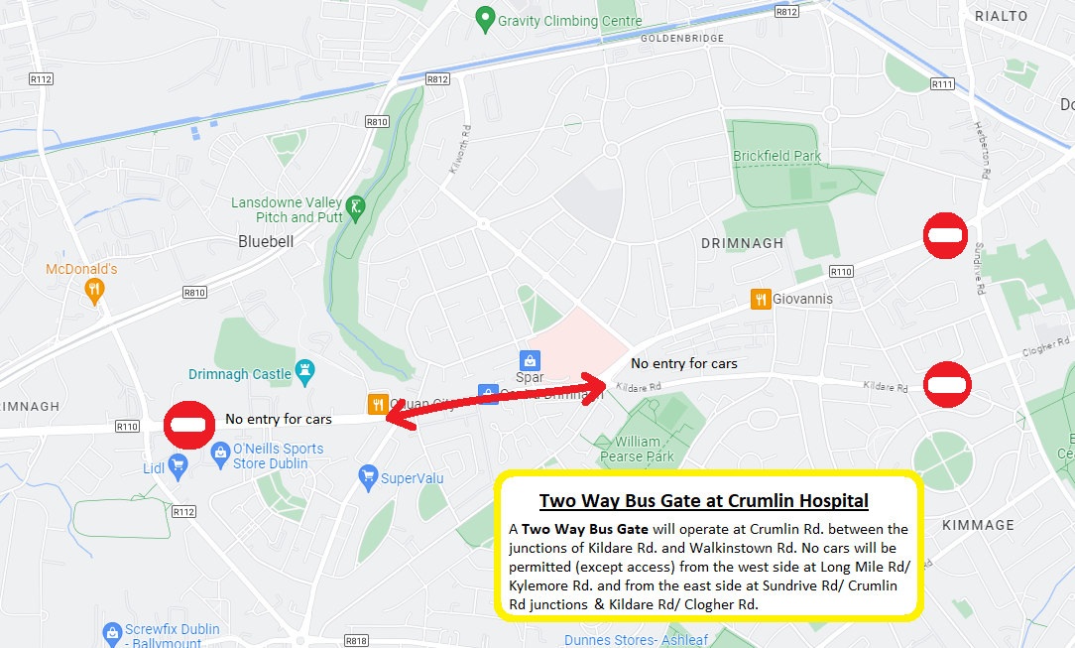

Dublin City Marathon Monday Race Day Temporary Termini

 | TEMP. TERMINI | ROUTES | TIME
1 | Kildare rd | 122. | 0800 Until stood down
2 | James's St Hospital | 123. | 0800 Until stood down
3 | Newmarket | 27, 56a, 77a, 150, 151. | 0800 Until stood down
4 | Adelaide Road/ Hatch St. | 14, 15/a/b, 65b. | 0800 Until stood down
5 | Wolfe Tone Quay | 13, 52, 68 & 69. | 0800 Until stood down
6 | Sussex Road | 11, 46a, 145. | 0800 Until stood down

Chief Inspectors, Inspectors & Operatives Locations:

Chief Inspector In Charge, Dublin Marathon | : G Coll
0800 Until stood down
Merrion Gates {to man diversion turn}
0800 Until stood down
Beach Rd/Church St{to man diversion turn}
0800 Until stood down
Walkinstown Ave {to ensure diverted routes take right turn to Long Mile Road}
0800 Until stood down
Wolfe Tone Quay {to supervise temp termini for C spine etc}
1100 to finish at Aston Quay (Cony Rd early Insp)
0800 Until stood down
Kildare Rd {to man 122 temp. Terminus}
0800 Until stood down
Newmarket
1000 to race finish Hawkins Street {to man temp. termini at both locations}
0800 Until stood down
Hatch Street/ Adelaide Rd. {to man 14, 15/a/b, 46a, 65b, 145 temp. Termini}
1000 to race finish Nassau Street
0800 Until stood down
James’s Hosp. {to man 123 temp termini}
0800 Until stood down
Kildare Road/Drimnagh Road Bus Gate {to supervise operation of buses at crossover point and ensure efficient and safe operation}
Bridges
Macken St Bridge 0800 Until stood down
Erne St Bridge 0800 Until stood down
Sandwith St Bridge 0800 Until stood down

Area Garda in Charge:
TBC | Start/Finish Area
 | Bridewell
 | Castleknock to Sarsfield Road
 | Inchicore/ Rialto/ Crumlin Road
 | Walkinstown to Terenure
 | Clonskeagh to Belfield
 | Milltown to Pembroke Road
 | Garda Control Room

On Street Area Road Reopen Times
2022
Nth/ Sth Quays | TBC | Crumlin Vill.
Manor St. |  | K.C.R
Castleknock |  | Fortfield Rd.
Chapelizod |  | Templeogue Rd.
Sarsfield Rd. |  | Terenure X.
Kilmainham |  | Orwell Rd.
Crumlin Rd. |  | Milltown
Walkinstown Rd. |  | Clonskeagh Rd.
Cromwellsfort Rd |  | Fosters Avenue
 |  | Pembroke Rd.

